Lab Report

Course: Computer Networks (CN)  
Lab: 1  
Student: 23BCP182

# Aim

To study different types of network topologies: Bus, Star, Ring, Mesh, and Hybrid.

# Theory

A network topology refers to the arrangement of elements (links, nodes, etc.) of a communication network. Topologies can be physical or logical. Below are the commonly used types:

## Bus Topology

All devices share a single communication line. Simple but has collision issues. 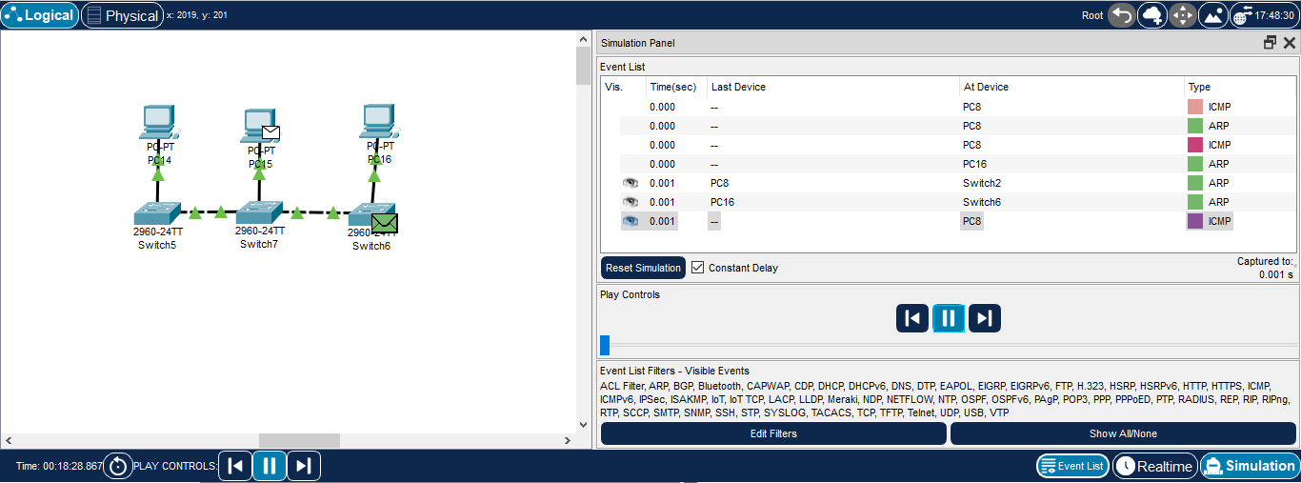

## Star Topology

All devices connect to a central hub/switch. Easy to manage but hub failure affects network. 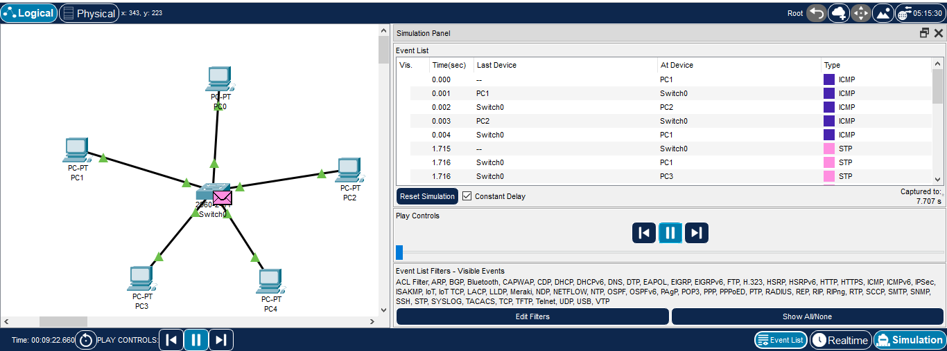

## Ring Topology

Each device is connected to two others forming a ring. Data flows in one direction. 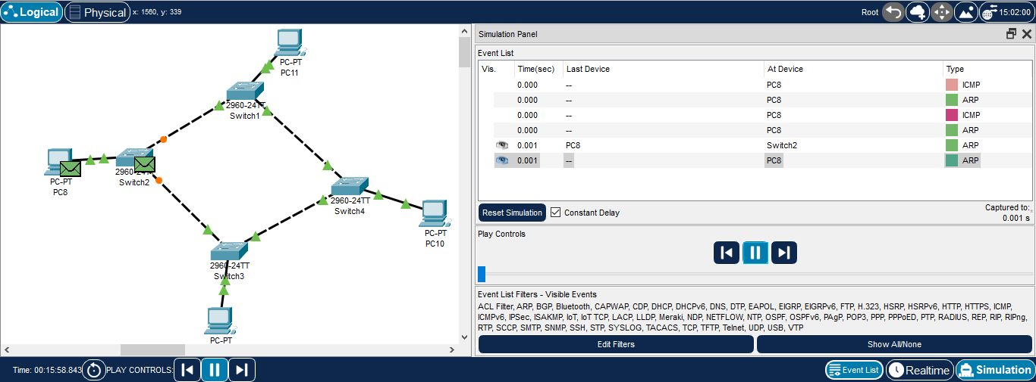

## Mesh Topology

Each device is connected to every other device. Provides redundancy but is costly. 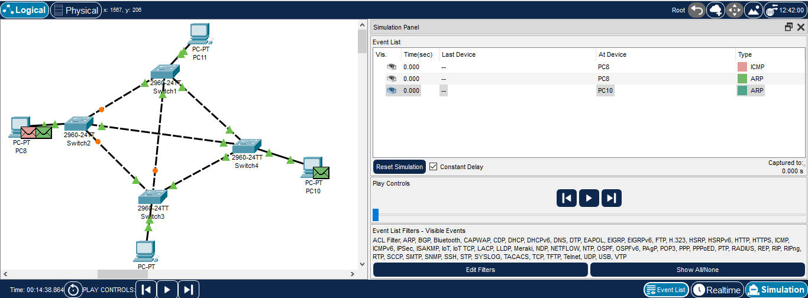

## Hybrid Topology

Combination of two or more topologies for better efficiency. 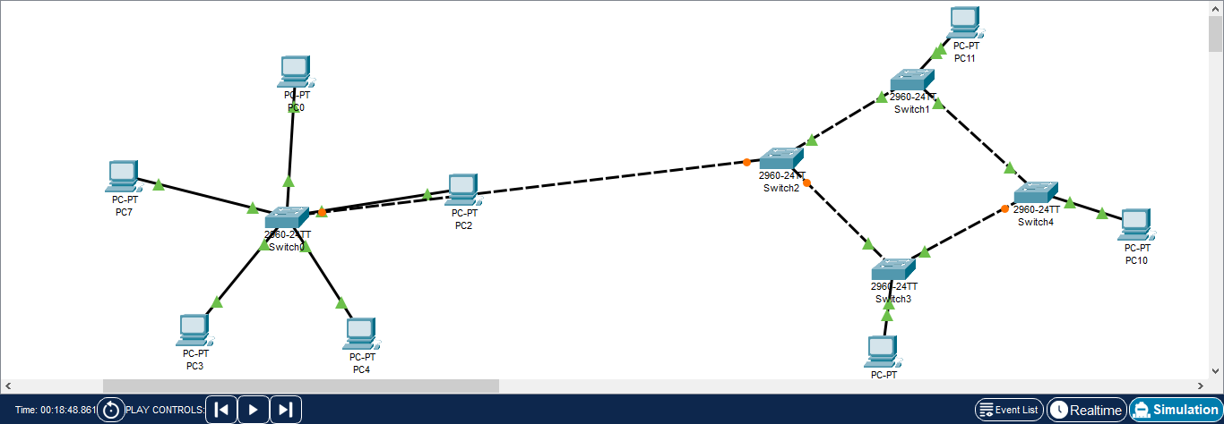

# Procedure

1. Study the definition and characteristics of each topology.  
2. Draw the structure/diagram for each topology.  
3. Note down advantages and disadvantages.  
4. Compare topologies based on cost, reliability, and efficiency.

# Result

Different types of network topologies were studied and their characteristics understood.

# Conclusion

Each topology has its own advantages and limitations. Star topology is widely used due to its simplicity and scalability, while Mesh provides robustness at higher costs. Hybrid topologies are often used in large organizations.